DBMS LAB MANUAL

Name: Mymoon Beevi.B Roll. No:230701222

Working with constraints

**Ex.no.4:**

1.ALTER TABLE EMP ADD CONSTRAINT my_emp_id_pk PRIMARY KEY(Employee_id);

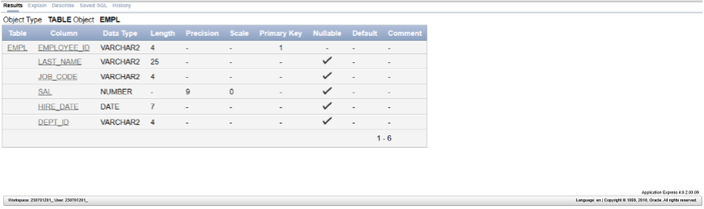

2. ALTER TABLE DEPT ADD CONSTRAINT creation PRIMARY KEY(ID);

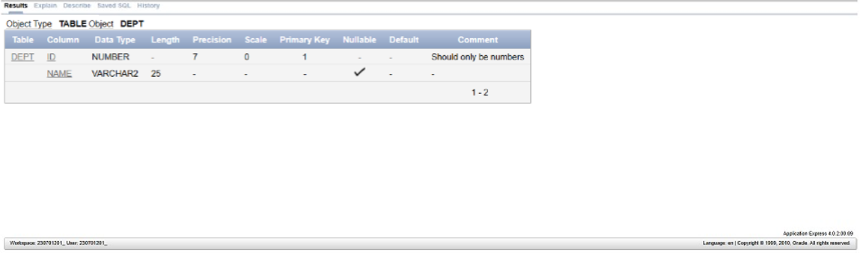

3. ALTER TABLE EMPL ADD DEPT_ID varchar(4);

ALTER TABLE EMPL ADD CONSTRAINT my_emp_dept_id_fk FOREIGN

KEY(DEPT_ID) references DEPT(ID);

4. ALTER TABLE EMPL ADD COMMISSION number(7);

ALTER TABLE EMPL modify COMMISSION number(2,2);

ALTER TABLE EMPL ADD CONSTRAINT com_check CHECK(commission&gt;0); 